**First Aeroplane Efficiency World Record established**

**on a C182 equipped with SMA Aero-diesel engine**

Two pilots completed a flight to establish the first Aeroplane Efficiency World Record in the C-1-c class as sanctioned by the *Fédération Aéronautique Internationale* (the organization sanctioning aviation world records). Ross Mc Curdy, a high school teacher in Rhode Island, Thierry Saint Loup, an executive at SMA Engines (Safran Group) in Texas took off from the Essex County airport in New Jersey on July 12th in a Cessna 182 from the Paramus Flying Club equipped with a highly efficient compression ignition engine from SMA. The triangular course was 848 Nm (1572 km) completed in 9.1 hrs using only 56 gallons of fuel resulting in an efficiency of 15.1 Nm per gallon, a world record in its class.

Take Off:  Tuesday July 12th 2016          9:29 AM  EST

Landing:  same day                                  6:35 PM  EST

KCDW Essex County Airport Caldwell, New Jersey

Flight Time:  9 hours 6 minutes

The Bioplane was weighed prior to taking off from Caldwell Airport and weighed again after landing at Caldwell to determine the amount of fuel used and the efficiency attained.

Fuel Used: 56 gallons of aviation biofuel blend

6.18 gallons per hour

Flight Route: KCDW to KBUF to KPWM back to KCDW

Essex County Airport Caldwell, New Jersey to Buffalo, New York to Portland, Maine and back to Caldwell

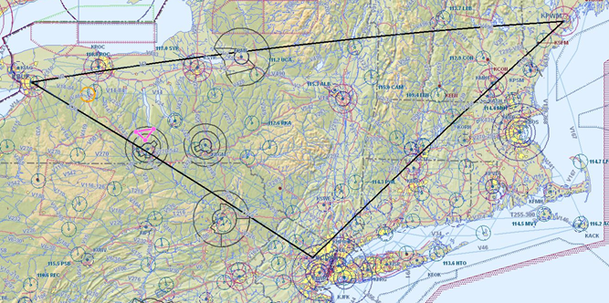

This achievement sets an efficiency standard for the new generation of piston engines operating on jet fuel, or biofuel blends. The SR305-230 engine produced by SMA (Safran Group) is a certified piston engine in production operating on Jet fuel designed specifically for operation in light aircraft with its simple design, redundant systems and light weight consuming up to 40% less fuel than current gasoline engines. Its installation on the C182 is FAA and EASA approved under a Supplemental Type Certificate (STC) developed by SMA and now available from Soloy Aviation Solutions in Olympia, Washington. Due to its high efficiency, this engine allows the C182 to fly up to 1300 Nm non-stop, or to carry more payload for shorter missions, a significant advantage over the Avgas engine it replaces.

The flight was completed near max gross weight in a standard, FAA certified configuration without any modification that would have required placing it in experimental category. This efficiency record is therefore achievable in just about any aircraft equipped with an SMA engine. This World Record also demonstrates the potential of aviation biofuels and all renewable energy, as the flight was completed using 50% biofuel from the Camelina plant seed oil.

Thierry Saint Loup (left) and Ross McCurdy after completing the Fuel Efficiency World Record Flight at Essex County Airport Caldwell, New Jersey.

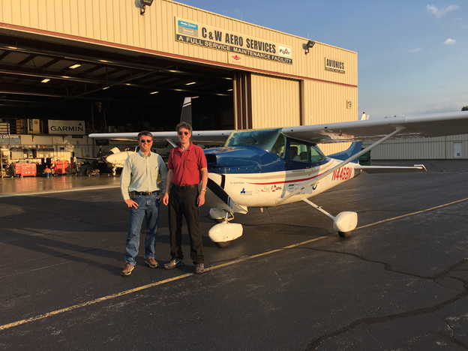

**Additional information:**

**Biofuel:** Aviation biofuel made from Camelina plant seed oil and blended 50-50 with petroleum Jet A to meet ASTM D7566 specifications.  The aviation biofuel blend was provided by the US Air Force and the Bioflight will provide further performance information on the use of biofuel in an Aviation Diesel Engine.

**Plane:**  Registered as N4468N, it is a four passenger, single-engine Cessna 182 equipped with an SMA aviation Diesel engine ([www.smaengine.com](http://www.smaengine.com)). STC available from Soloy Aviation Solutions ([www.soloy.com](http://www.soloy.com))

**Pilot:  Thierry P. Saint Loup**

Thierry is Vice President of SMA Engines, the company that makes the advanced aviation diesel engine powering the flight.  Thierry is a graduate of Embry-Riddle Aeronautical University where he earned a degree in Aviation Technology along with his Commercial/multi engine/instrument Pilot’s License and Aircraft & Powerplant mechanic’s license.  Thierry is also a glider pilot and an expert on Aviation Diesel Engines.  Thierry is originally from France and is now living just outside Dallas, Texas.

**Pilot: Ross McCurdy**

Ross is a Science Teacher at Ponaganset High School in Rhode Island where he teaches Chemistry and Alternative Energy.  He holds a Commercial Pilot’s License and Instrument rating and is a recipient of the 2015 Presidential Innovation Award for Environmental Educators.  [www.protium.us](http://www.protium.us/) and [www.biodieselpickup.blogspot.com](http://www.biodieselpickup.blogspot.com/) include photos and other information on previous renewable energy projects achieved with the students and members of the Ponaganset community.

The **Aero Energy Association** is a Rhode Island non-profit with the mission to promote aviation and renewable energy through education, demonstration, and application.

**Paramus Flying Club** is one of the oldest flying clubs in the country and serves the New York City and New Jersey area.  [www.flyingclub.org](http://www.flyingclub.org)

Contact: **Ross McCurdy** [**rkmccurdy@yahoo.com**](mailto:rkmccurdy@yahoo.com)cell: 401-241-6506

**Thierry Saint Loup** [**tsaintloup@smaengine.com**](mailto:tsaintloup@smaengine.com) cell: 386-679-6856